BRIEFING ON THE VACCINATION:16 FEBRUARY 2021
The release of the results of the AZ vaccine on the 6th February 2021 disrupted the rollout of the vaccination programme, mainly because the AZ vaccine was shown to be less effective against the 501Y.V2 variant which was first discovered in South Africa and was predominantly responsible for the second wave. At the same that these bad news were announced, Johson&Johnson (J&J) had just released the results of their Phase 3A Sisonke trial led by MRC in South Africa which showed that this vaccine had 57% efficacy against the mild to moderate COVID, 85% against severe COVID and 100% in preventing deaths. This presented an opportune moment to pursue this vaccine but with the vaccine unregistered anywhere globally, the best approach was to use a trial approach to access these vaccines. This is called an open label phase 3B, which is more of an implementation research as its efficacy has now been proven. This can also be described as the “Early Access to effective treatment that is awaiting registration of some call it compassionate use to save lives. This has been done commonly with anti-cancer drugs to save lives whilst the administrative regulatory processes are still being managed.

For this early access programme, a protocol had to be approved by SAHPRA so that the doses could be accessed from J&J, and these are the doses that were manufactured for research and were found efficacious. J&J was generous to offer those doses and the first tranche is arriving this evening (16 February 2021) so that we are able to start on Wednesday, 17 February 2021. Since these doses had to be accessed through a special approval by SAHPRA, the first sites needed to be linked with the existing MRC research sites for compliance with research protocols. This is a stop gap arrangement until the drug receives emergency use approval (EUA) by all the regulatory bodies, then we will revert to the planned programme. The product to be used is as efficacious or the same as the one that will be manufactured after licensing. For the first 14 days, there will be 17 sites and these will be increased when the second batch comes in the next 14 days.

The First batch of sites are:
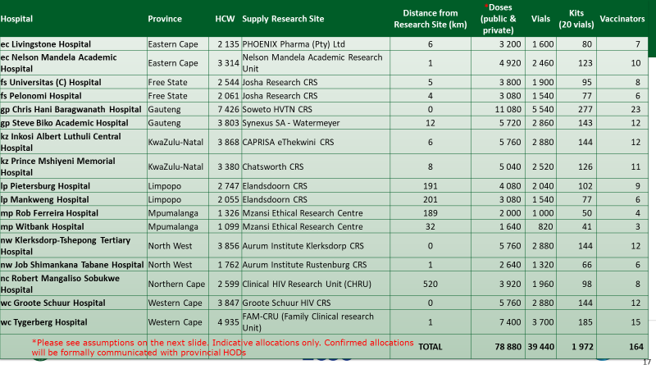

The phases will still remain the same as follows:
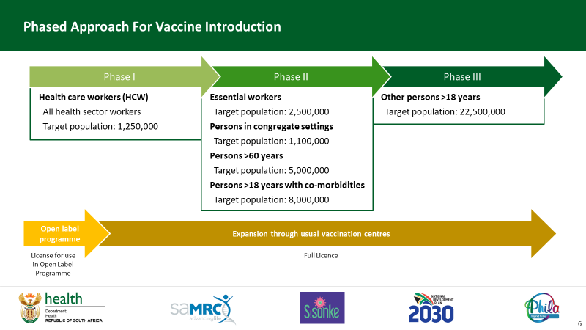

All sites will be ready to start on Wednesday, 17 February 2021, at 14:00 and all arrangements have been made with sites which have been linked with different institutions in provinces. We are grateful to the team that has been working tirelessly on these arrangements on a continuous basis is composed of MRC, Provincial Coordinators as well as the provincial MRC coordinators and their list is below:
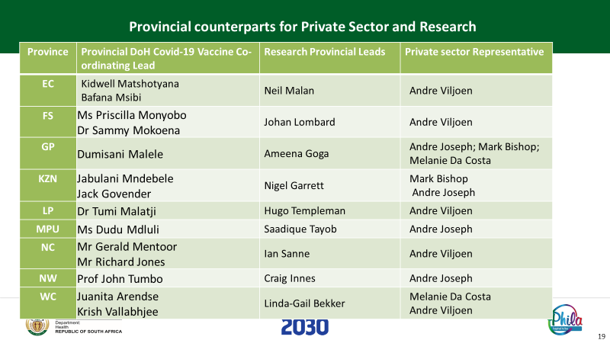

In addition, a briefing meeting for HODs was held on Saturday, 13 February 2021 to brief them on the whole plan. In addition, all unions were briefed on Monday, 15 February 2021. In all these meetings, MRC participated. We were very encouraged to see unions today speaking positively about vaccination on national TV.

MANAGEMENT OF VACCINE HESITANCY/RELUCTANCE
We developed a special request in discussion with MRC to vaccinate senior leaders as part of managing vaccine hesitancy and leading from the front. We developed a list that included the Ministers, Premiers, MECs and Health Sector Union Leaders but unfortunately we could not get protocol deviation approval for those who do not have a health background. This means that only Ministers, Premiers, Deputy Ministers and MECs who have a health qualification. This is merely a regulatory issue and as soon as we are back to the normal planned roll-out, will be able to address this issue. Union Leaders will qualify as they are health workers.
We expect all sites to start tomorrow. It has been very difficult as most issues were managed as we are moving forward, and some are still being finalized.

